WHAT WE DO

CCP12 is a global association of 37 members who operate more than 60 individual CCPs globally across EMEA, the Americas and the Asia-Pacific region. CCP12 aims to promote effective, practical and appropriate risk management and operational standards for CCPs to ensure the safety and efficiency of the financial markets it represents. CCP12 leads and assesses global regulatory and industry initiatives that concern CCPs to form consensus views of its members and seeks to actively engage with regulatory agencies and industry constituents through consultation responses, forum discussions and position papers.

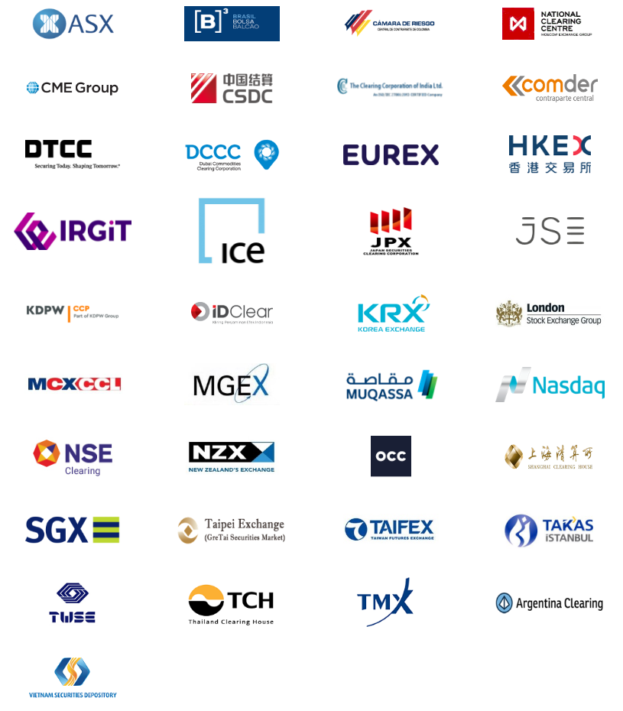

CCP12 HISTORY

CCP12 was formed in 2001 by major central counterparty organizations in Europe, Asia and the Americas to share CCP related information and to develop analyses and policy standards for common areas of concern. In 2008, CCP12 held its Annual Meeting in Tokyo and endorsed the collaboration by forming an Executive Committee to govern the global agenda. Later in 2015, the CCP12 General Assembly decided to register CCP12 as an official association in Shanghai, China. The CCP12 office was opened in 2017.

我们做什么

全球中央对手方协会（CCP12）是一个由37个成员组成的全球性协会，这些成员在欧洲、中东、非洲、美洲和亚太地区运营着60多个单独的中央交易市场。CCP12旨在促进中央对手方（CCPs）形成有效、实用和适当的风险管理和运营标准，以确保其代表的金融市场的安全和效率。CCP12领导和评估涉及CCPs的全球监管和行业倡议，以形成其成员的共识，并寻求通过政策反馈、论坛讨论和立场文件与监管机构和行业成员积极接触。

CCP12的历史

CCP12由欧洲、亚洲和美洲的主要中央对手方组织于2001年成立，旨在分享CCP相关信息，并针对共同关注的领域制定分析和政策标准。2008年，CCP12在东京举行了年会，并通过成立执行委员会来管理全球议程，从而认可了这种合作。后来在2015年，CCP12大会决定将CCP12注册在中国上海，成为一个官方实体运营的协会。CCP12办公室于2017年成立。