
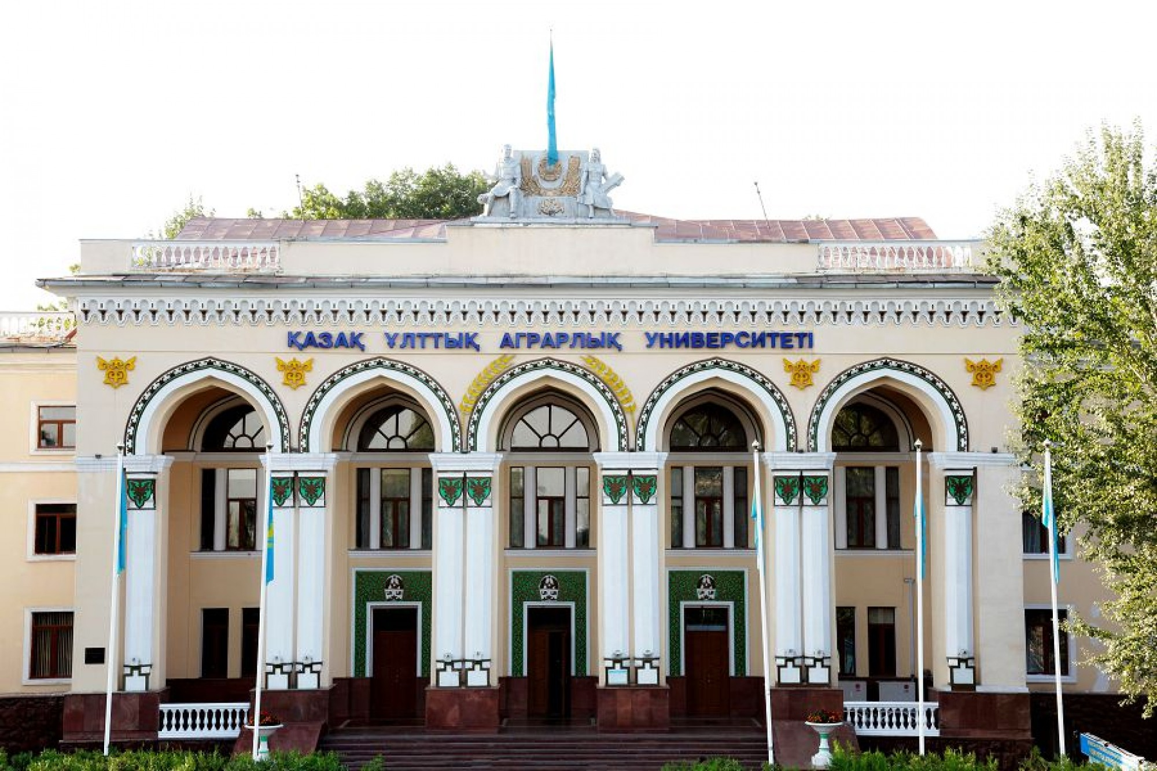


INFORMATION LETTER
Dear undergraduates and young scientists!

Non – Profit Corporation "Kazakh National Agrarian University" organizes the International Master's Winter School IWS - 2019
International Master's Winter School is held in the following areas:
- "Water Resources Management" "Green Economy"
- "Innovative Technologies and Technical Means in Agriculture"
- "Management of Natural Resources" -
- "Agro innovation in Plant Growing"
- "Veterinary"
- "Biotechnology and Food Safety"

The purpose of the International Master's Winter School IWS- is to obtain new knowledge, practical skills, mastering of innovative technologies and methods of scientific research.
Short Annotation. The students have a unique opportunity to participate in the School, increase their knowledge and acquire practical skills in educational programs. Lectures, master / training classes and round tables held by leading scientists of the Kazakh National Agrarian University, foreign scientists from the Universities of France, Germany, Slovakia, Lithuania, Russia and Belarus, as well as representatives of Scientific Research Institutes, will contribute to the formation of professional and interpersonal competencies of undergraduates.
Field study will be conducted in the following organizations: "Balkhash-Alakol Basin Inspection for Regulation of Use and Protection of Water Resources", "Bartogai Reservoir and the Great Almaty Canal named after DA Kunayev", "Holding Almaty Su", "Kazakh Scientific Research Institute for Economy of Agro Industrial complex and Development of Rural Territories", "Regional Veterinary Laboratory of Almaty", "Antigen", "Bayserke Agro", "Kazakh Scientific Research Institute for Mechanization and Electrification of Agriculture", "Scientific Center of Anti-infectious diseases", "Kazakh Scientific Research Institute for Biological Security Problems", as well as in the Kazakh-Japanese, Kazakh-Korean, Kazakh-Belarusian Agro-Engineering, Water Innovation Center, the Scientific and Educational Innovation Center of other innovative centers of the Kazakh National Agrarian University.

Working language: English.

Terms of participation in the International Master's Winter School IWS-2019:
- it is necessary to fill out the participant's registration form before 20 January (Appendix 1);
- an electronic version of the registration form should be sent to the email address kaznauipo@gmail.com

Preliminary program
International Master's Winter School IWS -2019
Date and time | Events
 | Arrival and accommodation of participants
 | Registration of participants
 | Opening of the International Master's Winter School
 | Plenary session
 | Educational courses
 | Closing Ceremony. the delivery of Certificates
 | Cultural events and departure of participants

Participants can publish scientific articles on topical problems of fundamental and applied research in the field of agricultural, veterinary, biological, technical, and economic sciences in the scientific journal of KazNAU "Student, research, results". The requirements for the article are attached (Appendix 2).
Organizing Committee
050010, Almaty, Abay Ave., 8
non-profit joint-stock company
"Kazakh National Agrarian University"

Contact phone numbers:
1. Director of the Institute of Post-Graduate

Education

Erkimbekuly Rauan

8 (727) 264-69-02;
2. Head of the Department of Magistracy
Kusainova Zhanar

8 (727) 262-17-63;
3. Head of the Department of International Scientific Projects
Yesperova Bayan

8 (727) 264-19-95
E-mail address:
kaznauipo@gmail.com
yesperova@gmail.com (For Foreign Students)

Appendix 1

REGISTRATION FORM OF THE PARTICIPANT
INTERNATIONAL MASTER’S WINTER SCHOOL IWS - 2019
FULL NAME. (completely)
Year and date of birth
Country
University, specialty
Choosing a School Direction
Contact phone numbers
E-mail address
Address and place of residence
Arrival/departure time

Appendix 2
Requirements for article
1. Articles are published in Kazakh, Russian and English. Manuscripts should be carefully verified and edited by the authors. Articles must be signed by all authors. The volume of the manuscript should be at least 3 pages long and contain the results of your own research. Review articles are not accepted.
2. Manuscripts are sent in electronic and paper form, in one copy, printed on one side of an A4 sheet in the Times New Roman editor, size 12, interval -1, paragraph 1, indents 2.5 cm above and below, on the left - 3 cm and on the right - 1.5 cm, according to GOST 7.5-98 and GOST 7.1-2003.
3. Elements of the article should be arranged in the following order: UDC (upper left); through the center interval in bold - the name, patronymic, surname of the author (s); through the interval in italics the name of the organization (city) where the author (s) work; through the interval in the center of the title of the article in capital letters.
4. Before the main text is written an abstract to the article in the original language in a volume of not more than 10 lines and keywords.
5. The text should include, as a rule, introduction, materials and methods, research results and their discussion, conclusions, list of literature. After the list of literature, indicate in 2 other languages marked from the original article, author (s), article title, abstract (at least 4-5 lines) and keywords. Figures and diagrams should be clear. If they are performed on graphic objects, they must be presented on separate sheets. In the references used literature all authors / co-authors of this publication are inscribed.
6. Section titles: introduction, materials and methods, results and discussion, the conclusions should be placed with a red line, and highlighted in bold without a period.
7. The underline, bold and italic text in the text is not allowed.
8. Articles in the journal from university employees are accepted in the presence of an expert opinion, articles from outside organizations - a cover letter, review and expert opinion of the organization on the possibility of publication.
9. On a separate sheet, it is necessary to give information about all authors: full name, academic degree, full name of the organization, its address, telephone, fax, e-mail.

对于文章的要求

1. 文章发表以哈萨克语，俄语和英语为主。作者应仔细核实并编辑稿件。论文必须由所有作者署名。手稿的内容应不少于3页，并包含自己的研究成果。不接受概述性的文章。
2.稿件为电子版和纸质版，每份印在A4纸的一面，Times New Roman字体， 12号字，间距为1，段落为1，上下空格 - 2.5厘米，左 - 3厘米，右 - 1.5厘米，按照GOST7.5-98和GOST7.1-2003标准。
3. 文章的基本要素应该为以下顺序： UDC (左上); 空个格后粗体字– 名,父称,姓;空个格后以斜体字方式写组织（城市）名称，作者工作地点；空个格后在中间以大写字母写文章标题。
4.算上关键词, 在主文前用原始语言所写的摘要不超过10行。
5.文本应包括，前言，材料和方法，研究成果及其讨论，结论，参考文献。 参考文献后应用区别于原文语言的其它2种语言来写作者的姓名，文章的标题，摘要（至少4-5行）和关键字。图片和表格应该是明确的。如果有图表形式，则它们必须呈现在单独的纸上。 本出版物的所有作者/共同作者都应出现在连接中。
6. 章节名称：前言，材料和方法，结果和讨论，结论应为红色字体，并以不加点的粗体显示。
7. 下划线，粗体和斜体在文章中是不允许的。
8.大学工作人员的期刊文章在有专家鉴定的情况下可以被接受，来自第三方组织的文章应带有附函，评论和专家关于文章发表可能性的意见。
9.在单独的纸张上 应该写上所有作者的信息：姓名，学历，单位全名，以及单位的地址，电话，传真，电子邮件。

