填表说明

此样式为研究生毕业证书和学位证书英文翻译认证样式；

中文证书为本人毕业证和学位证原件的扫描件（可缩印）；

中文证书扫描件与英文翻译文字保持在同一页面内，不可分开打印；

英文翻译可参考学校的文本（证明中文本红色加粗部分文字为证件持有人的实际信息，请如实填写，打印时用黑色打印）或对照证书原件如实翻译。

制作完成后联系所在学院研究生办老师审核并预约学校公章； 预约成功后，在南校区交流中心413盖章。

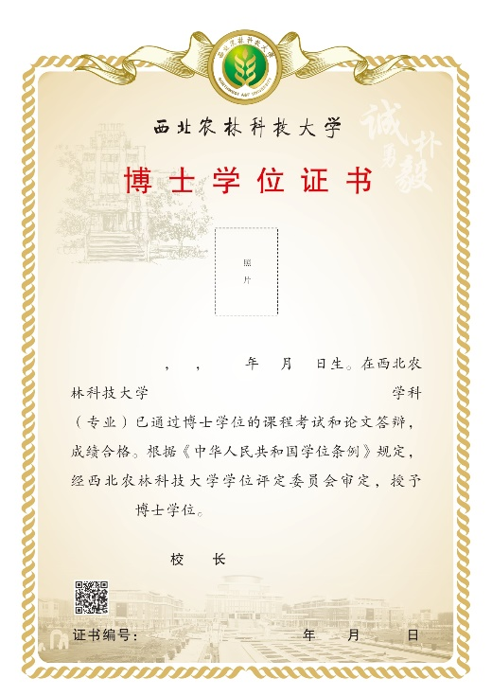
Certificate of Doctor’s Degree

This is to certify that Ms./Mr. Shi Jue, born on May 22, 2000, specialized in Agronomy of Northwest A&F University, has completed the doctor’s degree courses examinations and thesis defense with qualified standard. Upon the accreditation of the Academic Degree Evaluation Committee, Northwest A&F University, and in conformity with the Regulations on Academic Degrees of the People’s Republic of China, she/he is hereby awarded the Doctor’s Degree of Agriculture.

Wu Pute
President
Northwest A&F University
July 1, 2023
Certificate No. 1071222023000000

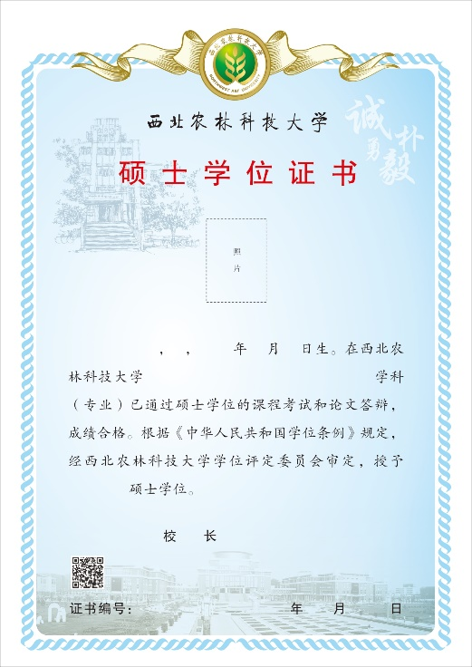
Certificate of Master’s Degree

This is to certify that Ms./Mr. Shi Jue, born on May 22, 2000, specialized in Agronomy of Northwest A&F University, has completed the master’s degree courses examinations and thesis defense with qualified standard. Upon the accreditation of the Academic Degree Evaluation Committee, Northwest A&F University, and in conformity with the Regulations on Academic Degrees of the People’s Republic of China, she/he is hereby awarded the Master’s Degree of Agriculture.

Wu Pute
President
Northwest A&F University
July 1, 2023
Certificate No. 1071232023010000

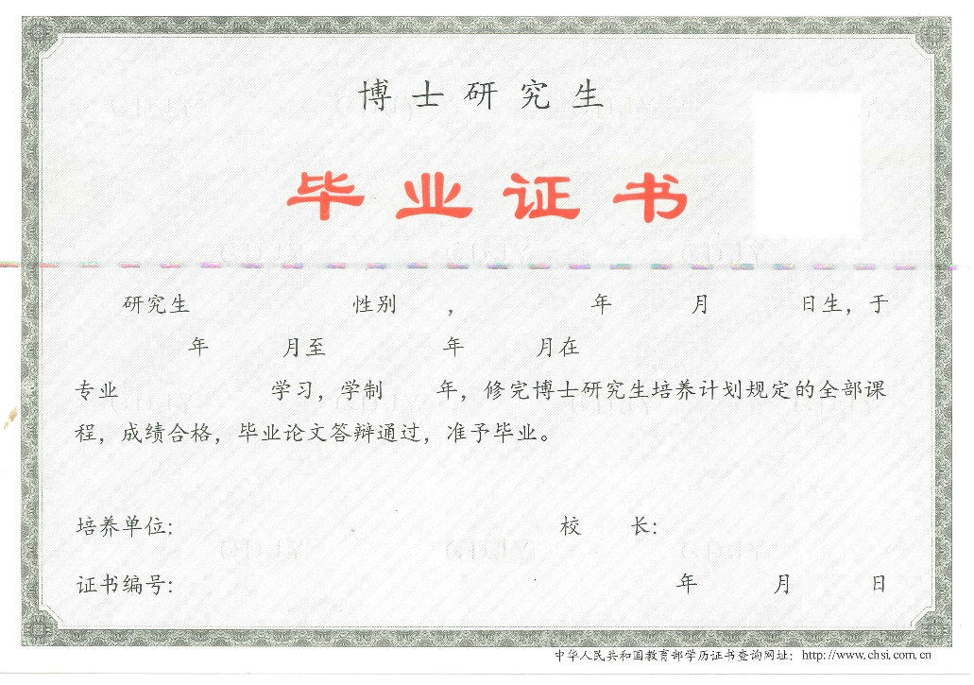
Certificate of Graduation

This is to certify that Ms./Mr. Shi Jue, born on May 29, 2000, having specialized in Agronomy of Northwest A&F University from September 2018 to July 2022 and completed the four-year doctor's courses and thesis defense with qualified standard, is hereby awarded this Certificate of Graduation.

Wu Pute
President
Northwest A&F University
July 1, 2023
Certificate No. 107121202301000000

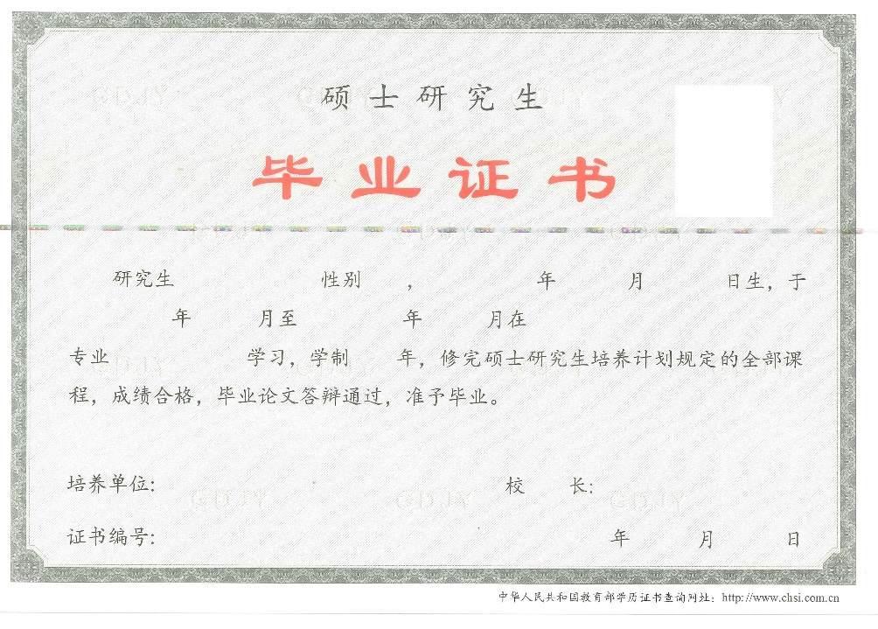
Certificate of Graduation

This is to certify that Ms./Mr. Shi Jue, born on May 29, 2000, having specialized in Agronomy of Northwest A&F University from September 2018 to July 2022 and completed the three-year master's courses and thesis defense with qualified standard, is hereby awarded this Certificate of Graduation.

Wu Pute
President
Northwest A&F University
July 1, 2023
Certificate No. 107121202302000000

