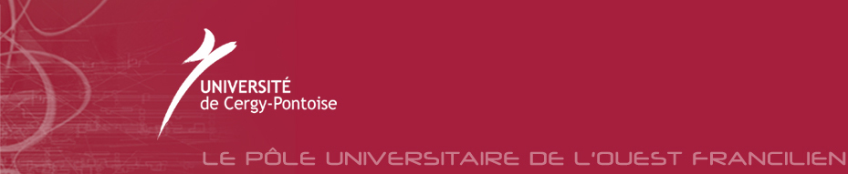
法国国立赛尔齐－蓬多瓦兹大学
理工学士英法双语项目介绍
特点与优势：
塞尔齐-蓬多瓦兹大学理工学士英法双语项目与其他大学有所不同，其特点与优势是：
- 学生无须在国外进行法语预科学习,而是直接进入大一专业学习，就读于塞尔齐-蓬多瓦兹大学理工学院。
- 大一专业课第一学期全部用英语授课，第二学期20%的课程用法语授课，但考试全用英语；大二专业课英法语言授课各自参半，而到大三期间绝多数用法语授课。
- 在大一和大二专业学习的同时，学校还提供大量法语学习课程，属于必修课，算学分。
- 在大一和大二专业学习期间，有专门老师给同学进行个性化辅导。
- 大一和大二专业学习主要课程有数学、计算机信息学、物理学或化学。在第三学年，学生可选择化学、数学与计算机、物理与模型制作、生命科学、工程师科学、地球科学与环境等专业方向,并获得国家理工学士学位。
- 获得国家理工学士学位之后，学生可选择的专业和方向更广，可以继续攻读学制2年的各类硕士课程，或者报考工程师学院，三年后便可获得法国工程师文凭和国家硕士。 学生也可选择报考工商管理学院，攻读工商管理硕士。

录取条件：
- 被录取国内一本院校的高中毕业生
- 英语托福雅思5.5/6.0分 （如果录取时没有成绩，可先获取大学正式录取通知书,然后参加雅思或托福考试）
- 有牢固的学习计划

国立赛尔齐－蓬多瓦兹大学大一入学时间：
2009年9月中旬入学

国立赛尔齐－蓬多瓦兹大学理工学士
第1和第2学年专业教学主要课程设置
学士一年级(L1)第1学期：
用英语讲授的统一课程及指导练习
－数学：集论、单项变量函数、序列、泰勒公式、对数、指数函数；
－物理：牛顿力学；
－化学：物质形态、化学平衡、电导率与pH值、氧化与还原概念；－计算机信息学：算法与编程语言引论(Java)；
学士一年级(L1)第2学期：
－数学：多项式环、欧几里德算法、里埃曼积分、微分方程、向量空间、线性应用、矩阵简化、凯莱－哈密尔顿定理；
－物理：狭义相对论、静电学、静磁学；
－化学：热力学与动力学；
－计算机信息学：程序、功能、表，等等。
学士二年级(L2)第3学期：
－数学：指定向量空间、多项变量函数、隐含函数定理、傅里叶级数、广义积分、巴纳赫空间、伊贝尔空间
－物理：波的传播；
－化学：无机化学－元素周期分类的普通特性、络合物、化学术语；原子论与键联、原子性能、化学键
－计算机信息学：算法与Java编程
学士二年级(L2)第4学期：
－数学：多重积分、向量场、格林里曼公式、二次形式、距离空间拓扑学；
－物理：热动力学、量子力学引论、统计力学引论；
－化学：有机化学－有机分子的性能(立体化学、光谱分析、结构)、反应分类、合成；
－计算机信息学：C语言编程；
实习：一个月
国立赛尔齐－蓬多瓦兹大学理工学士项目

学生感言

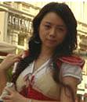 | Hello everybody. I'm Ding Yini,a girl from China. I joined the Bilingual program in 2003. In the first year, we had four majors:physics, maths, chemistry and computer science at the same time. It was really challenging. However,if you studied hard, nothing can trouble you. Last year I did Master in Modelisation of physics in cergy. Now I am going to finish my last of master in the University of Bretagne Sud,and my major is Modelling, Simulation and Optimisation. It's more on computer science and maths. I am very proud of being a member of this bilingue group.It has provided me with a strong scientific background.
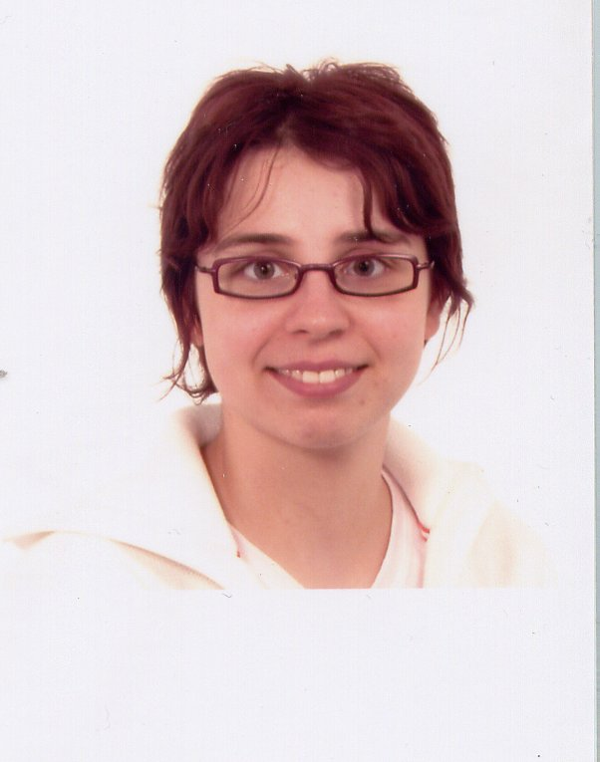 | Hi, my name is Olivia GUERRE and I belonged to the first group of bilingual students in 2001. I am French and was really happy to follow this program! If you are a prospective French student, don't be afraid of following classes in English: that's pretty interesting to learn science in another language and it's fairly easy to understand. Moreover you'll be able to communicate all over the scientific world and meet new people!! Thanks to the multidisciplinary program I was able to enter a Graduate School of Chemistry in 2003 (Ecole Nationale Superieure de Chimie de Lille) and now I am spending one year in the United States, at Michigan State University.
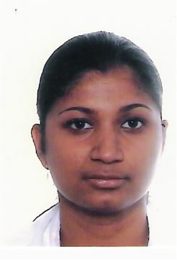 | Hi everybody, I'm Priya Ilango, I'm doing my final year of Master (Madocs) in the University of Cergy-Pontoise. I belonged to the first batch of Deug Bilingue, now it is called Licence Sciences et Technologies option Bilingue (equivalent to the bachelor degree). For me Deug Bilingue was an interesting course. During this course, I improved my English, because basically I'm a french student, and I had an opportunity to learn science in English.
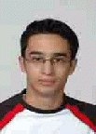 | Meeting different nationalities, different cultures, and friends from all over the world. That is great!!!! My name is Alaa Abouassi, I am Lebanese, I came to France in order to continue my studies, and the bilingual class was the only way for English speaking people who want to study in France. Because of this unique program, I was able to study French during the first two years of my bachelor, Scientific section (math, physics, computer science and chemistry), which helped me to integrate an engineering school in my third year, where all the disciplines are taught in French: Ecole polytechnique universitaire Pierre et Marie Curie, Paris-VI.
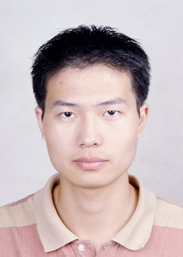 | Hi, it's me. One of the bilingual students in 2003. BAO Zhaohui. Call me BAO. Well, for the bilingual program, I was very happy to get a chance to continue my college study in France. Here we are not only continuing our study in English, also we get a chance to know many different cultures. Especially french (the country is beautiful). With excellent professors I got easy understanding and progressing. Also with friends, we pass happy time in the LAB while cooperating. Well, till now I still yearn those times. Now as the new academic year begins, I will soon (in 2008) finish my Master on Nanophysics at Grenoble (Université Joseph Fourier). On nanoscience with the new generation of technologies, people are doing some excellent work on this domain. That also attracts me to continue dive inside the real world of physics. And you are very wellcome to contact me if you are interested in physics.
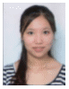 | Hello, my name is YingYan CHEN, I was the student of bilingual class in 2003, now I am studying in the Université Paris-sud 11 in Master 2 Professionnel: Instrumentation et méhodes d'analyse moléculaire. I am very grateful to my teachers help and the bilingual program. Study the science with 2 languages is so great and it will be very useful to your future career.
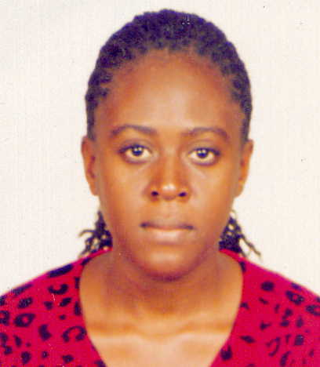 | Hi. I'm Sandra Namukose. I'm from Uganda. I joined the Bilingual program in 2003. At first, it was really challenging because we had to study physics, maths, chemistry,computer science and french at the same time. But with the help of the bilingual teachers, I gained confidence to sail through it. It has really been a rewarding experience for me academically and culturally. I'm currently in my last year of masters, majoring in Telecommunications at the university of Paris-Est Marne-la-vallee.
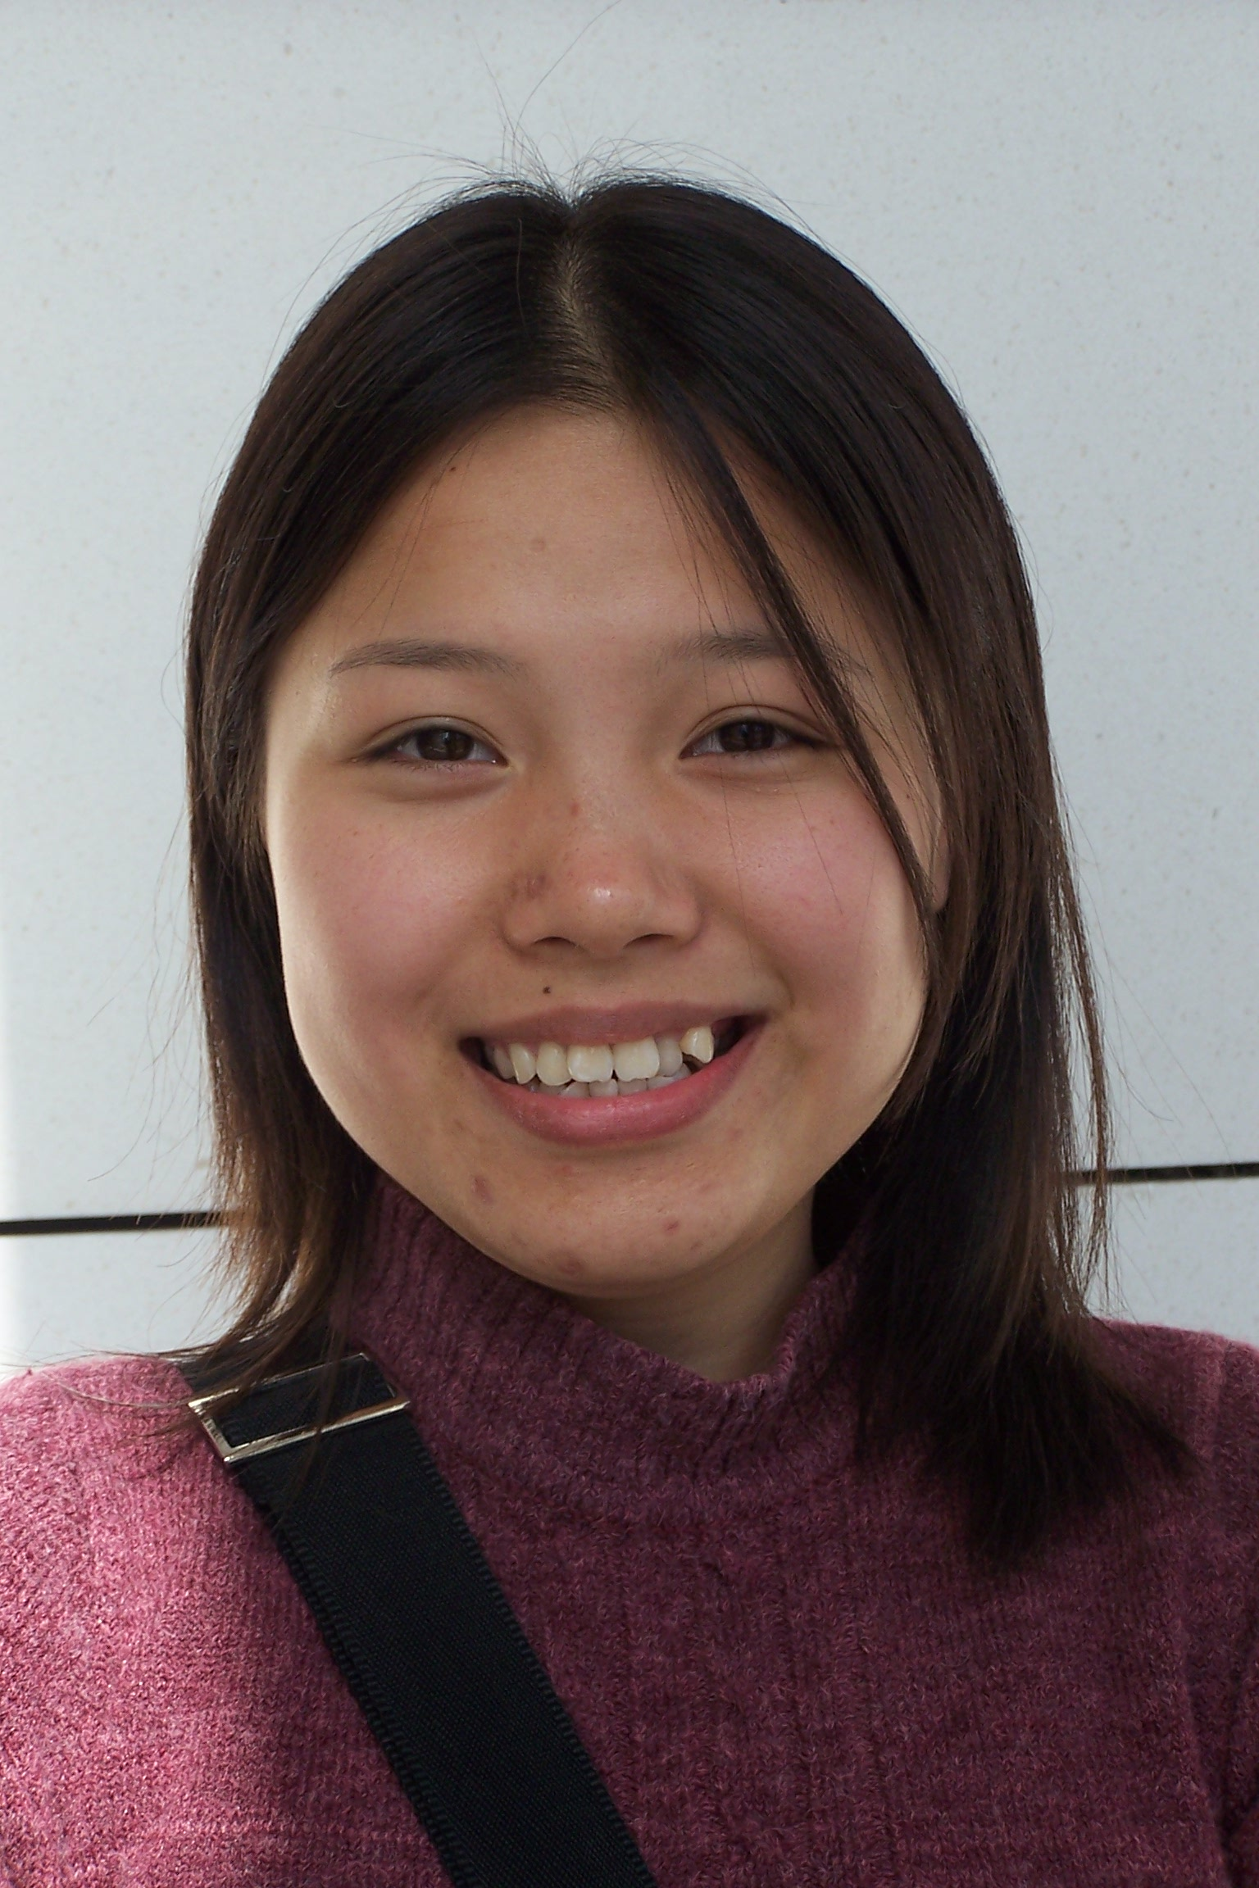 | Hi ! My name is Thanh Tu. I'm a Vietnamese student. After three years of undergraduate studies at the university of Cergy-Pontoise, I am now enrolled in the first year of the Master degree SI (Systèmes Informatiques). When I started my studies in 2002, I was in the bilingual group. It was a very interesting class. All my friends came from many countries. And the bilingual teachers are all so enthusiastic. I hope this bilingual program will become more and more developed in the coming years.
 | Hello, my name is Hu Minhui and I am a chinese girl. I am studying now in the "UNIVERSITE PIERRE & MARIE CURIE" (Paris VI), in M2 "physique experimentale des atomes et molecules". I have been so happy and proud to have studied at the University of Cergy-Pontoise in the bilingual class. When there, I have also studied French, and so many subjects. Teachers are there so nice, always ready to help. The bilingual class is also a place where you can make a lot of friends. It changed my life, why not yours!
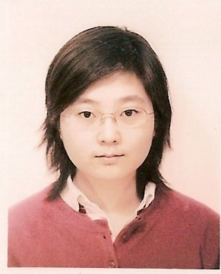 | Hello, everybody. I'm ZHANG Chi, from CHINA. I belonged to the first group of bilingual students in 2001. Now I'm learning chemistry in master 1 in university of cergy-pontoise. I am very glad to choose bilingual program, because when I came to france, I had no base of French. So I could study, improve my English and French at the same time. All the teachers from bilingual group are very kindly and patient. I think it's a good experience for me and also for you !

赛尔齐－蓬多瓦兹大学
Université de Cergy-Pontoise
学校网址：http://www.u-cergy.fr
学校概况  赛尔齐－蓬多瓦兹大学是一所于1991年7月新创办的综合大学。  - 11 250名学生；  - 284名教师－研究员；  - 220名兼职教授  主要学科专业：  - 5个教学与研究单位(UFR)：文学与人文科学、语言、法学、经济管理及科学与技术；  - 135种第一至第三阶段文凭。  科学研究、实验室：  - 理论、模型、信息中心；  - 地球材料、力学、土木工程、环境中心；  - 法学研究；  - 人文科学领域的跨文化活动；  - 实验研究组。  外国学生接待优势：  - CROUS(大区大学及学校事务管理中心)大学生公寓(相关预定条件须与CROUS联系)与私人公寓；  - 新生经水平测试后可修读外国语法语课程。  地理位置：  位于巴黎东北郊的瓦尔德瓦兹省，可乘坐RER城铁A线，距巴黎25公里 | 学校准确名称：赛尔齐－蓬多瓦兹大学  学校性质： 公立  学校主校区所在城市名称： 赛尔齐－蓬多瓦兹  在校学生人数：11250人  外国学生人数或比例：约10%  颁发文凭的性质及种类：学士/硕士/博士  是否为外国学生设法语课：有  是否为外国学生设辅导课程：有  是否设有英语教学的课程：有  2004/2005年注册费金额（参考标价）：  在334.57欧元至374.57欧元之间(包括学生社会医疗保险)  邮政地址  33, bd du Port 95 510 Cergy-Pontoise

赛尔齐－蓬多瓦兹大学排名

资料来源/Source：法国《新观察家》杂志(Le Nouvel Observateur)2003年3月12日

根据法国《新观察家》杂志(Le Nouvel Observateur)2003年3月12日发表的法国82所公立大学排行榜，赛尔齐－蓬多瓦兹大学排名为第32位，并且在巴黎地区17所公立大学中名列第七位。
在82所公立大学各类单项指标排名中，赛尔齐－蓬多瓦兹大学排名情况如下：
教学设施：第2名
教学方法：第19名
学生学业成功率：15e rang 第15名
活力：第31名
学生生活：第44名
求职：第48名

在26所大型综合性（卫生学科除外）大学各类单项指标排名中，赛尔齐－蓬多瓦兹大学排名情况如下：

学生学业成功率：第1名
教学设施： 第1名
教学方法： 第5名
活力：第8名
学生生活：第9名
科研：第11名
国际化：第15名

赛尔齐－蓬多瓦兹大学
理工学士英法双语项目费用

2009-2010 大一学年：共计 720 欧元
- 大学注册费：约180欧元
- 学生基本社会保险：约190欧元
- 一年法语学习费用（每周6小时以上，属国家补贴课程）：350欧元

2010-2011 大二学年：共计 720 欧元
- 大学注册费：约180欧元
- 学生基本社会保险：约190欧元
- 一年法语学习费用（每周6小时以上，属国家补贴课程）：350欧元

2011-2012 大三学年：共计 370 欧元
- 大学注册费：约180欧元
- 学生基本社会保险：约190欧元

